V.Y.W.S POLYTECHNIC BADANERA
(2022-2023)


CERTIFICATE
This is to certify that the Micro-Project Entitled has implementation of Java Script Program
Submitted by:-
JAY ANIL DENGEL
Third year computer technology
Is the particle fulfillment of diploma in computer technology
Guided By: Head of department Principal
Prof.Rajesh Tiwari Prof.Rajesh Tiwari Prof.R.M.Deshmuk

V.Y.M.S POLYTECHNIC COLLAGE, BADNERA
MICRO-PROJECT

Title Of Project : Java Script Program
Year / Sem : 3rd year ; 5th Sem
Branch : Computer Technology
Course : CSS
Course Code : 22519
Branch : Computer technology
Submitted By :-
Name : Jay Anil Dengle
Roll.no : 11
Enrollment No: 2001140030

Tools and technology used:
Sr.no | Name of resources | Specification | Qty.
1 | Windows | 7-10 operating | 1
2 | Editior | Notepad | 1
3 | Computer(min 2gb ram) | System | 1
4 | Coding language | Java script | --
5  6  7 | File  Software  Browser | Jdk 1.8.1  NetBeans  Chrome | 1  1  1

Step:
- Open notepad

- Write code (given below)

- Save file by .html extension

- Open That file by browse

- Progam is runned in web-browser

- Answer the Quiz Question

- Scrore Is Showen

CODE:

<!DOCTYPE html>
<!--
To change this license header, choose License Headers in Project Properties.
To change this template file, choose Tools | Templates
and open the template in the editor.
-->
<html>
<head>
<title>TODO supply a title</title>
<meta charset="UTF-8">
<meta name="viewport" content="width=device-width, initial-scale=1.0">

</head>
<body>

Q1. Javascript is an _______ language?<br>
<input type="radio" name="Q1" id="correct1" /> object oreinted<br>
<input type="radio" name="Q1"> Object Based<br>
<input type="radio" name="Q1"> Both<br>
<input type="radio" name="Q1"> None<br><br>

Q2. Which of the following keywords is used to define a variable in Javascript?<br>
<input type="radio" name="Q2"/> var<br>
<input type="radio" name="Q2"> let<br>
<input type="radio" name="Q2" id="correct2"> Both<br>
<input type="radio" name="Q2"> None<br><br>

Q3.Which of the following methods is used to access HTML elements using Javascript?<br>
<input type="radio" name="Q3"/> getElementByID()<br>
<input type="radio" name="Q3"> getelementbyclassname()<br>
<input type="radio" name="Q3" id="correct3"> Both<br>
<input type="radio" name="Q3"> None<br><br>

Q4.Upon encountering empty statements, what does the Javascript Interpreter do?<br>
<input type="radio" name="Q4"/> throws an error<br>
<input type="radio" name="Q4" id="correc4t"> ignores the statement<br>
<input type="radio" name="Q4" > gives a warning<br>
<input type="radio" name="Q4"> none of the above<br><br>

Q5.Which of the following methods can be used to display data in some form using Javascript?<br>
<input type="radio" name="Q5"/> document.getelement<br>
<input type="radio" name="Q5"> console.log()<br>
<input type="radio" name="Q5"> window.alert()<br>
<input type="radio" name="Q5" id="correct5"> all of the above<br><br>

Q6.How can a datatype be declared to be a constant type?<br>
<input type="radio" name="Q6"/> constant<br>
<input type="radio" name="Q6"> var<br>
<input type="radio" name="Q6"> let<br>
<input type="radio" name="Q6" id="correct6"> const<br><br>

Q7.What keyword is used to check whether a given property is valid or not?<br>
<input type="radio" name="Q7" id="correct7"/> in<br>
<input type="radio" name="Q7"> isin<br>
<input type="radio" name="Q7"> none<br>
<input type="radio" name="Q7"> both<br><br>

Q8.When an operator’s value is NULL, the typeof returned by the unary operator is:<br>
<input type="radio" name="Q8" id="correct8" /> cassandra<br>
<input type="radio" name="Q8" /> react<br>
<input type="radio" name="Q8" /> vue<br>
<input type="radio" name="Q8" /> node<br><br>

Q9.What keyword is used to declare an asynchronous function in Javascript?<br>
<input type="radio" name="Q9" id="correct9" /> async<br>
<input type="radio" name="Q9" /> await<br>
<input type="radio" name="Q9" /> none<br>
<input type="radio" name="Q9" /> both<br><br>

Q10.How to stop an interval timer in Javascript?",<br>
<input type="radio" name="Q10" id="correct10" /> clearinterval<br>
<input type="radio" name="Q10" /> cleartimer<br>
<input type="radio" name="Q10" /> none<br>
<input type="radio" name="Q10" /> both<br><br>

<input type="submit" value="SubmitQuiz" name="submit" onclick="result()" />
<script>
function result()
{
var score = 0;
if(document.getElementById('correct1').checked)
{
score++;

}
if(document.getElementById('correct2').checked)
{
score++;

}
if(document.getElementById('correct3').checked)
{
score++;

}
if(document.getElementById('correct4').checked)
{
score++;

}
if(document.getElementById('correct5').checked)
{
score++;

}
if(document.getElementById('correct6').checked)
{
score++;

}
if(document.getElementById('correct7').checked)
{
score++;

}
if(document.getElementById('correct8').checked)
{
score++;

}
if(document.getElementById('correct9').checked)
{
score++;

}
if(document.getElementById('correct10').checked)
{
score++;

}
alert("Your Score Is::-- "+score);
}
</script>
</body>
</html>

Output:

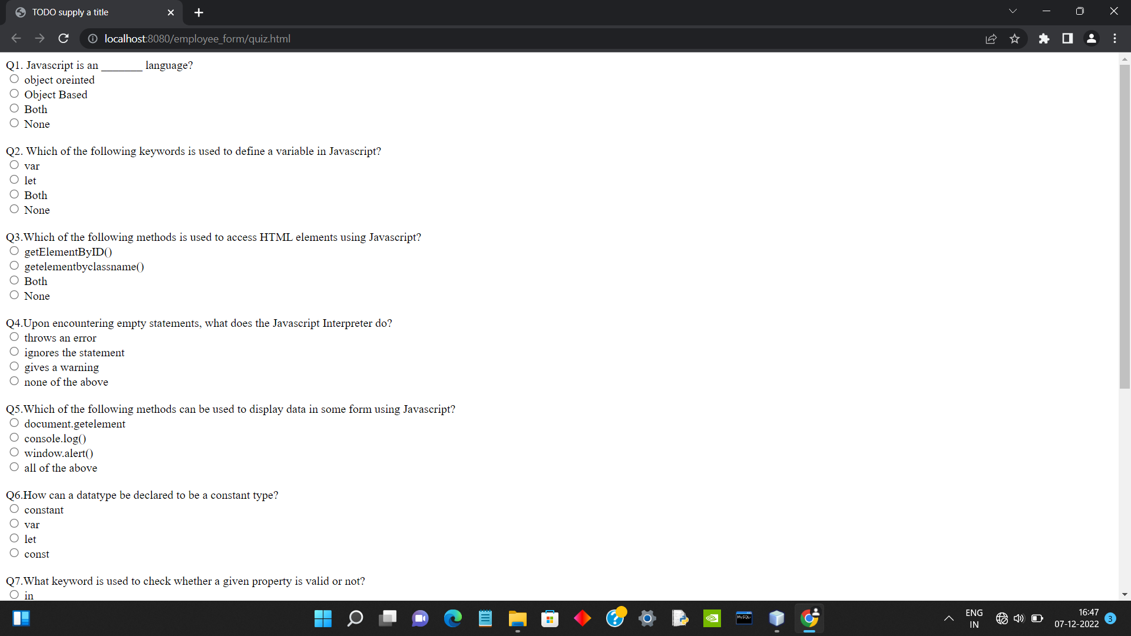

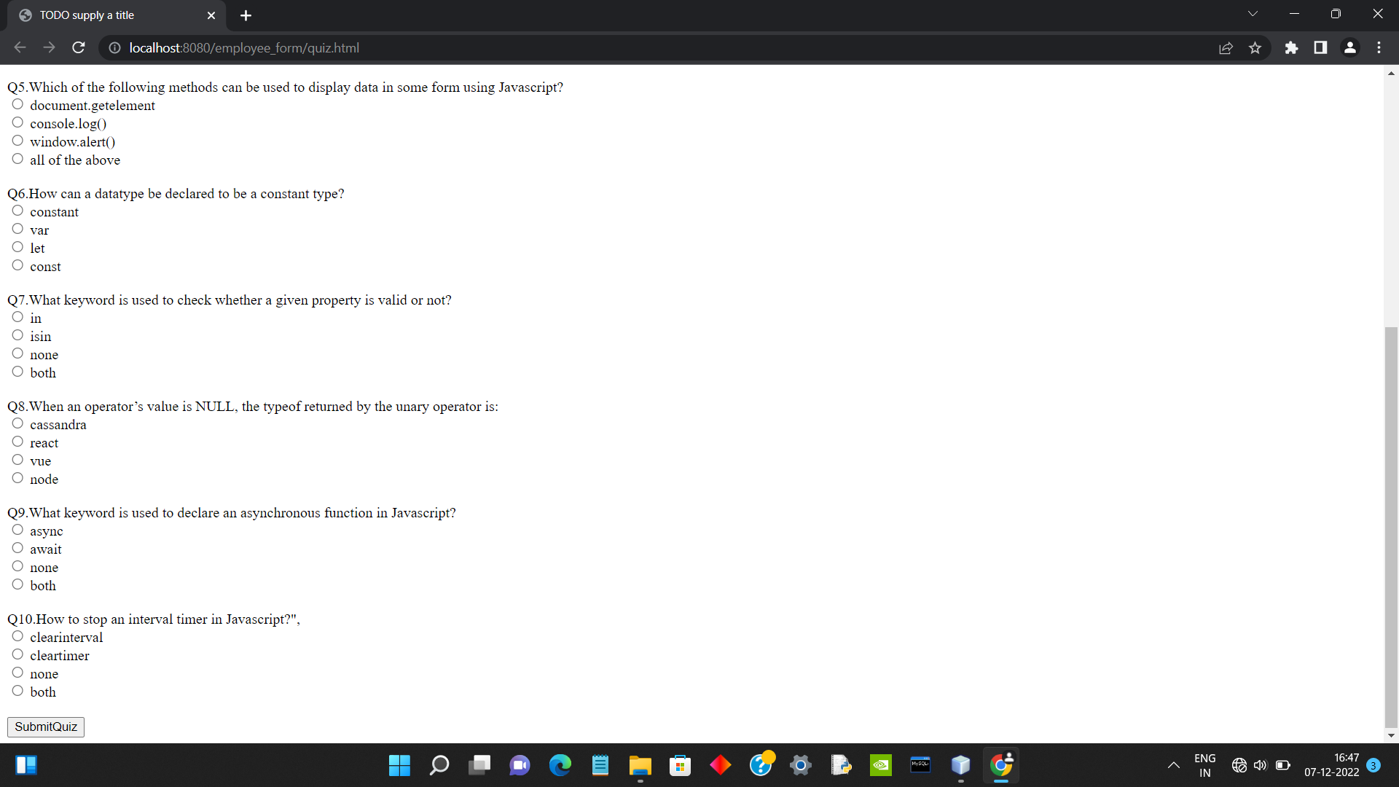

Thank
you

